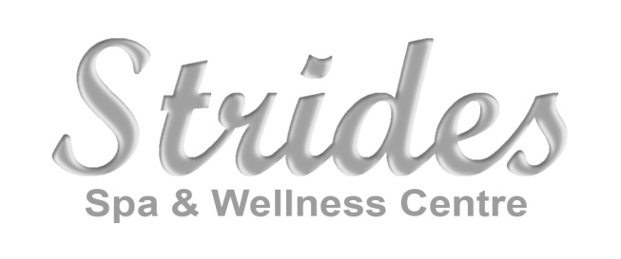
Job Opportunity for:
Esthetician, Lash Technician and Nail Technician
550 Hwy #2
Elmsdale, NS
www.stridesspa.ca

We are searching for a superb esthetician, lash technician and nail technician who has a passion for client relations, who "starts and stays" and shows loyalty to their workplace and clients. Our bright and modern spa is truly inviting, and our team wants to welcome someone who is hard working and eager for continuing education. We are a high demand family spa/salon with a full-service co-ed fitness facility. Located just 10 min from Halifax International Airport and 20 min from HRM, this is a great opportunity for a new or experienced technician.
Strides Spa and Wellness Center opened in 2014. We pride ourselves on offering high quality services in a modern, professional, chic environment with exceptional administrative support and we can cater to medium-sized groups allowing for 4 pedicures at a time.
Offering: Hair, Esthetics, Massage Therapy, Reflexology/Craniosacral Therapy, Acupuncture, Reiki, Cosmetic Medicine, Cosmetic Laser services.
- Mornings, Evenings, Occasional Saturdays (flexible days/hours)
- Generous wage plus commission and cash tips
- Health Benefit Plan available and employee discounts and incentives
- Great potential to build a full clientele in our growing community of East Hants
- 10 min drive from the Halifax Airport, free/ample parking
- Position available immediately
Visit us at www.stridesspa.ca for a comprehensive view of our services.
Contact:
Leslie Wilber-Campbell
President
Strides Spa and Wellness Center
(902)221-5568 – direct line
stridesspa@ns.aliantzinc.ca

