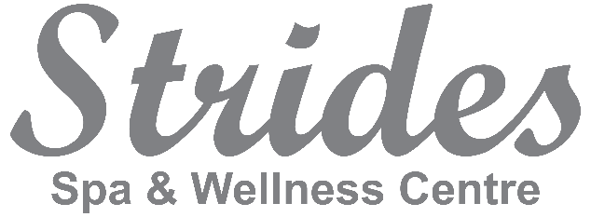

Job Opportunity for:
Hair Stylist
550 Hwy #2
Elmsdale, NS
www.stridesspa.ca

We are searching for a superb hair stylist who has a passion for client relations and shows loyalty to their workplace and clients. Our bright and modern salon is truly inviting, and our team wants to welcome someone who is hard working and eager for continuing education. We are a high demand family spa and wellness center located just 10 min from Halifax International Airport and 20 min from HRM. This is a great opportunity for a new or experienced stylist.
Strides Spa and Wellness Center opened in 2014. We pride ourselves on offering high quality services in a modern, professional, chic environment with exceptional administrative support.
Offering: Hair, Esthetics, Massage Therapy, Reflexology/Craniosacral Therapy, Acupuncture, Reiki, Cosmetic Medicine, Cosmetic Laser services. Physiotherapy and psychology in the same building.
- Employment opportunity with commission and cash tips - Mornings, Evenings, Occasional Saturdays (flexible days/hours)
- Chair Rental option – negotiable
- Health Benefit Plan available and employee discounts and incentives
- Great potential to build a full clientele in our growing community of East Hants
- 10 min drive from the Halifax Airport, free/ample parking
- Position available immediately
Visit us at www.stridesspa.ca for a comprehensive view of our services.
Contact:
Leslie Wilber-Campbell
President
Strides Spa and Wellness Center
(902)221-5568 – direct line
stridesspa@ns.aliantzinc.ca

