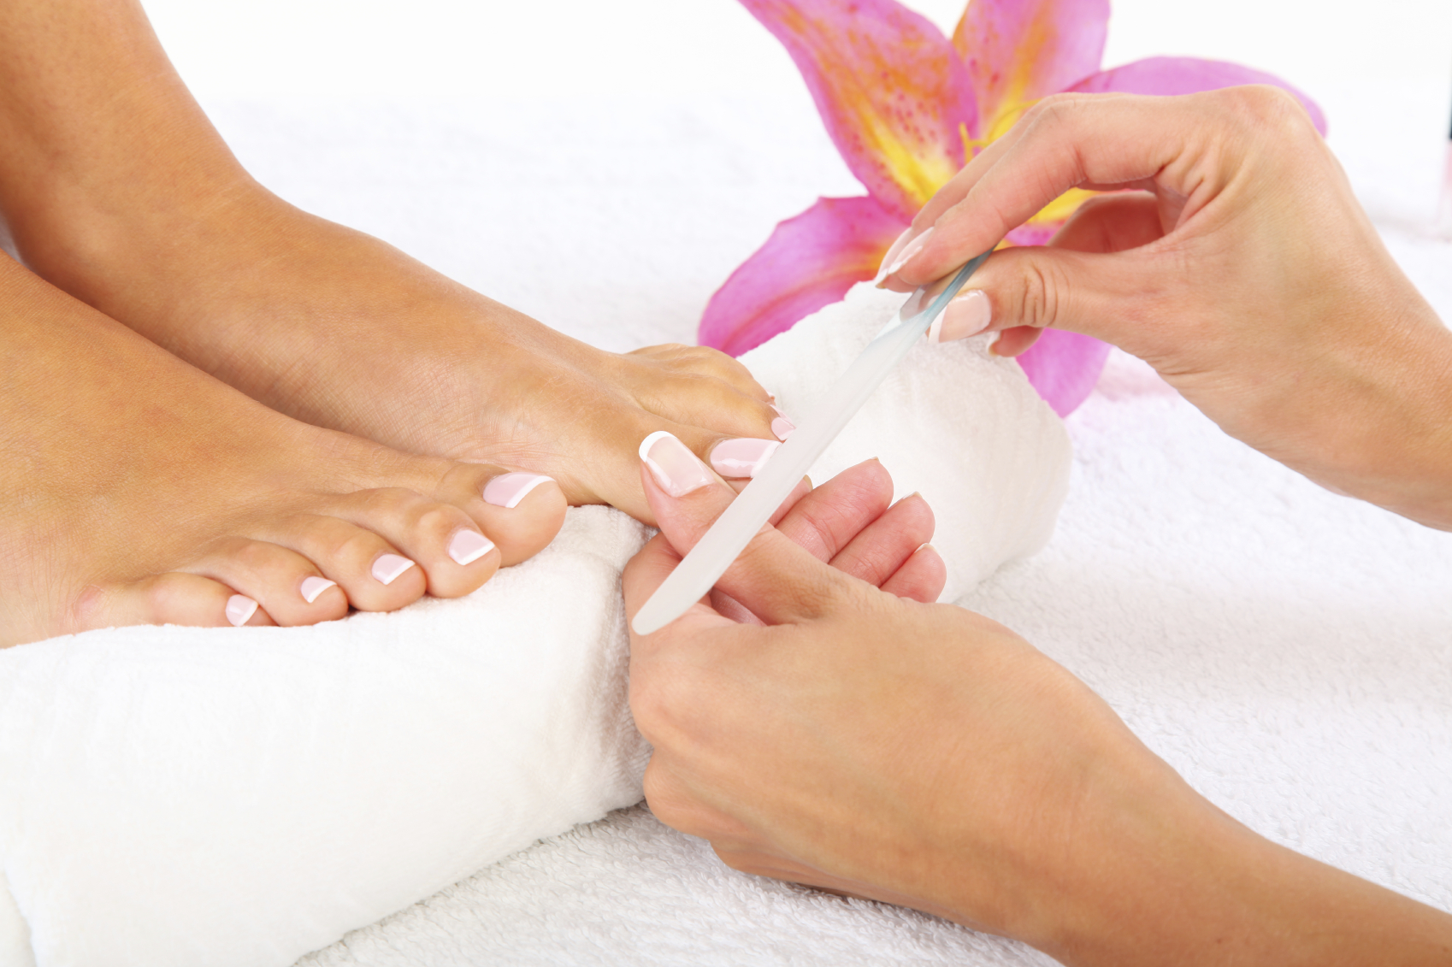
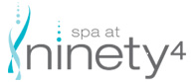 Attention

Spa at ninety4 is Hiring an Esthetician

Spa at ninety4 is a full service spa
located within the
Lunenburg Arms Hotel in the
beautiful historic town of Lunenburg

Offering various treatments, manicures, pedicures, massage therapy,
A variety of hair salon services, facials as well as medical esthetics.

The position is full time, 30-40 hours per week.

Would you like to join our team? Do you think you’re the right fit?
We’d love to hear from you…
Contact the General Manager Kim Smith-Crouse:
902-634-9094
And forward your cover letter, resume & portfolio to:
kcrouse@eden.travel

Hourse

