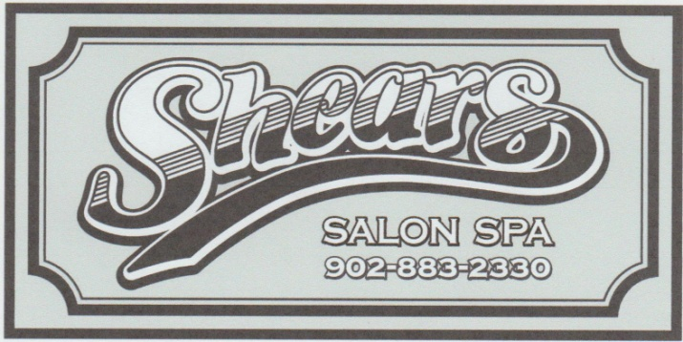

Esthetician needed

We are looking to hire an Esthetician/Nail Tech ASAP for Part Time/Full Time hours.
You must have a valid NS Cosmetology licence.
You will be required to perform Facials, Manicures, Pedicures, Body Waxing, Brow and Lash Tints and Relaxation Massages. Gel Nails and Lash Lifts would be an asset.

Please forward your resume to shears.elmsdale@gmail.com or drop it off in person. We are located at 3-295 Highway 214, Elmsdale NS

