HAIRDRESSING TREND CLASS
Nostalgic Revival
Artistry Collection 2024 by Armineh Damanpak

Presented by
CAPILEX & JOICO

COSMETOLOGY ASSOCIATION OF NOVA SCOTIA
126 Chain Lake Drive Halifax, NSB3S 1A2

May 27, 2024
9:00 am to 4:30 pm
For Info: Halifax Boutique
E-mail : halifax@capilexbeaute.ca
Phone : 902 450 6290

Nostalgic Revival Class Description:

Embrace the nostalgia of the 90s with a modern twist that redefines style. Armineh inspiration is rooted in the iconic fashion and super models of that era. Think vintage vibes infused with a modern edge. It's a unique mix that celebrates the best of both worlds, offering a chance to relive the past in a fresh, exciting way. Trend cut in the morning finished with the corresponding balayage and color technique in the afternoon.

Stylist Tools Required:
Scissors
Blow Dryer
Round Brushes
Denman Brush
Flat Iron
1” or 1.5” Curling Iron
Cutting Comb
Sectioning Clips
Foiling Comb
3 Color Bowls (if applicable)
3 Color Brushes (if applicable)

Price: $225.00 - 95062405 - (Maximum of 12 Stylists - non-refundable)
Approved for 1 Credit by CANS.

CLASS EDUCATOR

Armineh Damanpak
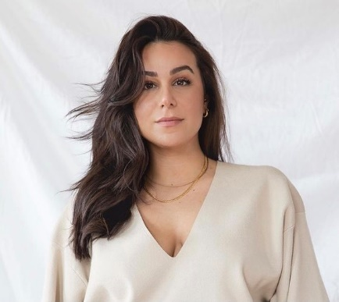

Armineh Damanpak is an award-winning stylist, with over 10 years of experience in the hair and beauty industry. Armineh has been internationally trained by the Vidal Sassoon academy and is most well known for her colour techniques which have been crafted through years of experience working alongside some of the industry’s top stylists.
Her signature look includes lived-in effortless hair, but she also creates bold unique looks to suit each and every guest with the mantra of emphasizing natural beauty. 5 years into her career she wanted to share her love of hair and started a new chapter as an educator and now owns her first salon.
Armineh has been nominated for multiple awards and has had the pleasure to work alongside various brands, creative agencies, film production companies and is well-versed in multiple facets of the hair industry, including work behind the chair, competitions, and editorial.

Class Supplied Items
Luxury Blonde Technique
Brown Mannequin Heads
6N LumiShine Demi Liquid x 1
8VG LumiShine Demi Liquid x 1
5 Volume LumiShine Developer
Blonde Life Powder Lightener
Blonde Life 20 Volume Developer
Pro Series 1 & 2
Joiwhip
Joimist Medium
Rise Up
Body Shake
Foils
Gloves

