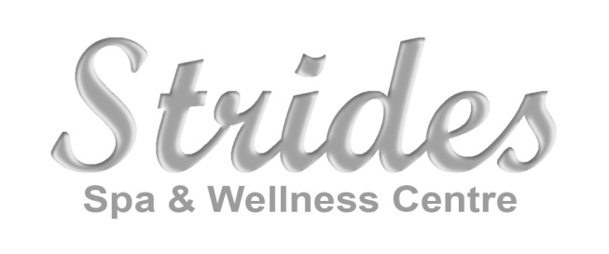
Job Opportunity for Hair Stylist and/or Barber
550 Hwy #2
Elmsdale, NS
www.stridesspa.ca

We are searching for a superb stylist who has a passion for client relations, who "starts and stays" and shows loyalty to their workplace and clients. Our bright and modern salon is truly inviting and our team wants to welcome someone who is hard working and eager for continuing education. We are a high demand family spa/salon with full service co-ed fitness facility. You will develop a full time clientele quickly. Just located 10 min from the Halifax International Airport and 20 min from HRM, this is a great opportunity for a new or experienced stylist and/or barber.
Strides Spa and Wellness Center opened in 2014. We pride ourselves on offering high quality services in a modern, professional, chic environment with exceptional administrative support. Each stylist has their own station.
Offering: Hair/Esthetics, Massage Therapy, Reflexology/Craniosacral Therapy, Reiki, Cosmetic Medicine (Botox, Juvederm), Cosmetic Laser services.
- Mornings, Evenings, Occasional Saturdays
- Generous wage plus commission
- Health Benefit Plan available, full gym membership to Strides Health & Fitness Club (1st level of MacMillan Center), 50% off all health, wellness and beauty services at our facility.
- Great potential to build a full clientele in our growing community of East Hants
- 10 min drive from the Halifax Airport, free/ample parking
- Position available immediately
Visit us at www.stridesspa.ca for a comprehensive view of our services
Contact:
Leslie Wilber-Campbell
President
Strides Spa and Wellness Center
(902)221-5568 – cell
lwilber@ns.sympatico.ca

