Cosmetology Association Preferred Rate

Atlantica Hotel
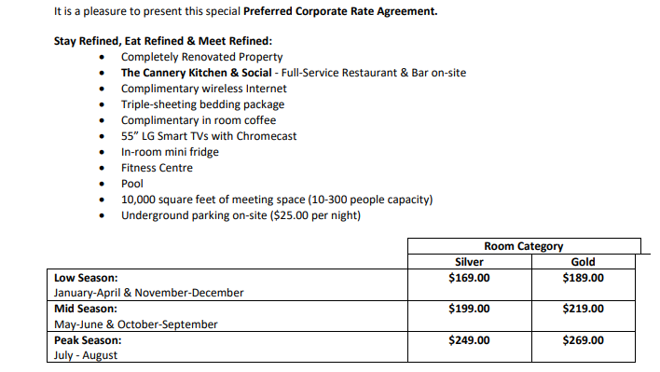
Reservations:
• Reservations recommended by calling the Atlantica Hotel Halifax directly at (902) 423-1161 or by email, reservations@atlanticahalifax.com
• Reservations must be guaranteed by credit card.

Hotel Policies:
▪ Check-in is from 3:00pm / Check-out is at 12:00am.
▪ Extra-person policy: $20.00 plus tax per room, per night to a maximum of 4 people per room (including children).
▪ Cancellation Policy: A 24 hour, by 4pm 1 day prior to the day of arrival, notice is required to avoid a
penalty equaling the 1st night’s room + tax.
▪ Early Departure Policy: A 24 hour, by 4pm 1 day prior to the day of departure, notice is required to avoid a penalty equaling 1 night’s room + tax.
▪ No-Show Policy: No-shows reservations will be charged for the 1st night room + tax and held for the 1st night only, the remaining room nights will be cancelled/released.
▪ Non-Smoking Policy: The Atlantica Halifax Hotel is a non-smoking hotel. It is strictly prohibited to
smoke/vape in the guest rooms and all interior public areas. A daily penalty of a minimum of $250.00+tax will be charged for any infractions.
▪ Pet Policy: The Atlantica Halifax Hotel is happy to welcome your furry family members; however, a $50.00 deep cleaning fee will be applied per stay.

Blackout Dates: • All statutory holidays • New Year’s Eve 2024

